HANDS-ON LAB GUIDE
Context Passing, Short-Term Memory & the Orchestrator
Extending the Orchestrator Agent lab so agents share information with each other and with a final Resolution Agent — entirely with plain Python and your existing local Qwen model.
Prepared for: Vodafone Technical Training Session
Format: Instructor-led, hands-on

1. Objective
By the end of this lab, students will be able to:
- Define and distinguish three core multi-agent concepts: Orchestration, Context Passing, and Short-Term Memory.
- Extend the Orchestrator Agent lab so a specialist's output is captured and passed forward, instead of being discarded once printed.
- Build a simple short_term_memory dictionary that accumulates the customer request, the Orchestrator's decision, and every specialist's finding over the course of one run.
- Build a Resolution Agent that reads the entire accumulated memory — not just the last message — to produce a final answer.
- Explain clearly to students why this in-process dictionary is a teaching model for short-term memory, and not a production memory system.

2. Key Concepts
This lab introduces three ideas that are easy to blur together. Keep them separate in how you explain them:
Context Passing — one agent's output is passed to another agent.
Short-Term Memory — the system maintains information from the current session and makes it available to subsequent agents/turns.
Orchestrator — decides which specialist agent should handle the request.
We can demonstrate all three with plain Python and the same local Qwen model used in every earlier lab — no new libraries or hosted services are required.

3. Lab Scenario
Use this Vodafone scenario, which deliberately touches two categories at once (billing and roaming) so the Orchestrator's single decision, and the memory built around it, are both visible to students:
Customer:
"My bill increased from £40 to £95.
I also travelled to Dubai and used mobile data.
Please explain what happened."

4. Architecture Overview
The request now flows through four stages instead of two: the Orchestrator picks a specialist, that specialist's finding is written into short-term memory, and a Resolution Agent reads the whole memory to produce the final answer.
CUSTOMER
│
▼
┌──────────────┐
│ ORCHESTRATOR │
│ AGENT │
└──────┬──────┘
│
decides agent
│
┌────────┬────────┐
▼ ▼
BILLING AGENT ROAMING AGENT
│ │
└────────┬────────┘
│
SHORT-TERM
MEMORY
│
▼
RESOLUTION AGENT
│
▼
FINAL ANSWER

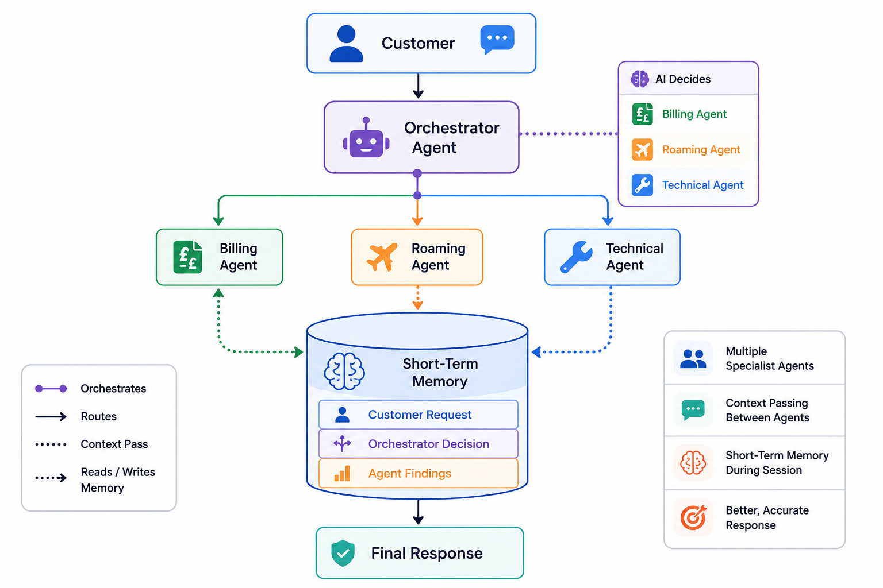
Figure 1 — The same architecture, showing what each agent reads from and writes to short-term memory.

5. Part 1 — Build multi_agent_memory.py
Create a file named multi_agent_memory.py with the content below. It is heavily commented in numbered steps so you can teach directly from the Python file rather than switching back and forth to slides:
import os
from transformers import pipeline

# ============================================================
# 1. IMPORTS
# ============================================================
#
# transformers gives us the local pipeline() function.
# os is unused directly but kept for parity with the earlier
# labs, in case students want to read environment variables
# (e.g. HF_TOKEN) later.
# ============================================================

# ============================================================
# 2. LOAD THE LOCAL MODEL
# ============================================================
#
# Same small local model as every earlier lab. Nothing about
# memory or context passing requires a different or larger
# model — it is entirely a Python-side pattern.
# ============================================================

ai = pipeline(
"text-generation",
model="Qwen/Qwen2.5-0.5B-Instruct"
)

# ============================================================
# 3. SHORT-TERM MEMORY
# ============================================================
#
# This dictionary IS our short-term memory. It is nothing more
# than a plain Python dictionary that lives for as long as this
# script is running.
# ============================================================

short_term_memory = {
"customer_request": "",
"orchestrator_decision": "",
"agent_findings": []
}

# ============================================================
# 4. ORCHESTRATOR AGENT
# ============================================================
#
# Reuses the reliable orchestrator pattern from the previous
# lab: few-shot examples, one-word answer, do_sample=False.
# ============================================================

def orchestrator(customer_request):
print("\n🤖 ORCHESTRATOR AGENT")
print("------------------------------------------")
print("Analyzing request...")

prompt = f"""
Your ONLY job is to choose the best specialist.

SPECIALISTS:

BILLING
Use for:
- High bill
- Unexpected charges
- Payment problems
- Plan charges

ROAMING
Use for:
- Travel abroad
- International usage
- Roaming charges

TECHNICAL
Use for:
- 4G or 5G problems
- Mobile internet not working
- Network problems
- SIM problems
- Phone connectivity problems

Here are examples:

Customer: My bill is £95 instead of £40.
Answer: BILLING

Customer: I travelled to Dubai and received roaming charges.
Answer: ROAMING

Customer: My 5G internet is not working.
Answer: TECHNICAL

Now classify this customer request:

Customer:
{customer_request}

Answer with ONLY ONE WORD:
BILLING
ROAMING
TECHNICAL
"""

messages = [
{"role": "system", "content": "You are a routing agent. Return only one category."},
{"role": "user", "content": prompt}
]

response = ai(messages, max_new_tokens=5, do_sample=False)
decision = response[0]["generated_text"][-1]["content"].strip().upper()

print(f"Decision: {decision}")

if "TECHNICAL" in decision:
return "TECHNICAL"
if "ROAMING" in decision:
return "ROAMING"
if "BILLING" in decision:
return "BILLING"

return "BILLING"

# ============================================================
# 5. BILLING AGENT
# ============================================================
#
# Notice this agent takes "context", not "customer_request".
# That single rename is what makes context passing visible in
# the code — the specialist no longer has direct access to the
# raw customer message, only to whatever context it is handed.
# ============================================================

def billing_agent(context):
messages = [
{
"role": "system",
"content": "You are a Vodafone billing specialist. Using the context "
"provided, explain the likely billing cause clearly and briefly."
},
{"role": "user", "content": context}
]
response = ai(messages, max_new_tokens=100, do_sample=True, temperature=0.7)
return response[0]["generated_text"][-1]["content"]

# ============================================================
# 6. ROAMING AGENT
# ============================================================

def roaming_agent(context):
messages = [
{
"role": "system",
"content": "You are a Vodafone roaming specialist. Using the context "
"provided, explain the likely roaming cause clearly and briefly."
},
{"role": "user", "content": context}
]
response = ai(messages, max_new_tokens=100, do_sample=True, temperature=0.7)
return response[0]["generated_text"][-1]["content"]

# ============================================================
# 7. TECHNICAL AGENT
# ============================================================

def technical_agent(context):
messages = [
{
"role": "system",
"content": "You are a Vodafone technical support specialist. Using the "
"context provided, give a short, practical troubleshooting suggestion."
},
{"role": "user", "content": context}
]
response = ai(messages, max_new_tokens=100, do_sample=True, temperature=0.7)
return response[0]["generated_text"][-1]["content"]

# ============================================================
# 8. SPECIALIST LOOKUP TABLE
# ============================================================
#
# Connects the Orchestrator's text decision to an actual
# Python function, exactly as in the orchestrator lab.
# ============================================================

SPECIALISTS = {
"BILLING": billing_agent,
"ROAMING": roaming_agent,
"TECHNICAL": technical_agent
}

# ============================================================
# 9. RESOLUTION AGENT
# ============================================================
#
# This agent receives the ENTIRE short_term_memory dictionary,
# not a single string. It builds its own context from all
# three pieces of memory before answering.
# ============================================================

def resolution_agent(memory):
findings_text = "\n".join(
f"- {f['agent']}: {f['finding']}" for f in memory["agent_findings"]
)

context = f"""
Customer Request:
{memory["customer_request"]}

Orchestrator Decision:
{memory["orchestrator_decision"]}

Specialist Findings:
{findings_text}
"""

messages = [
{
"role": "system",
"content": "You are a Vodafone customer resolution specialist. Using the "
"full context below, give the customer a clear, short explanation "
"and a recommended next step."
},
{"role": "user", "content": context}
]
response = ai(messages, max_new_tokens=150, do_sample=True, temperature=0.7)
return response[0]["generated_text"][-1]["content"]

# ============================================================
# 10. START THE DEMO
# ============================================================

print("\n==========================================")
print(" VODAFONE MULTI-AGENT MEMORY DEMO")
print("==========================================")

# ============================================================
# 11. GET THE CUSTOMER REQUEST
# ============================================================

customer_request = input("\nCustomer: ")

# ============================================================
# 12. STORE THE REQUEST IN MEMORY
# ============================================================
#
# The very first thing that goes into short-term memory is the
# customer's own request — everything else builds on top of it.
# ============================================================

short_term_memory["customer_request"] = customer_request

# ============================================================
# 13. ORCHESTRATOR DECIDES
# ============================================================

selected_agent = orchestrator(customer_request)
short_term_memory["orchestrator_decision"] = selected_agent

# ============================================================
# 14. BUILD CONTEXT FOR THE SPECIALIST (CONTEXT PASSING)
# ============================================================
#
# The specialist does not receive the raw customer_request on
# its own. It receives a context string built FROM short-term
# memory — the original request AND the Orchestrator's
# decision. This is context passing in action.
# ============================================================

context = f"""
Customer Request:
{short_term_memory["customer_request"]}

Orchestrator Decision:
{short_term_memory["orchestrator_decision"]}
"""

specialist_function = SPECIALISTS[selected_agent]
specialist_result = specialist_function(context)

# ============================================================
# 15. RUN THE SPECIALIST AND UPDATE MEMORY
# ============================================================
short_term_memory["agent_findings"].append(
{
"agent": selected_agent,
"finding": specialist_result
}
)

print("\n🤖", selected_agent, "AGENT")
print("------------------------------------------")

print(specialist_result)

print("\n🧠 SHORT-TERM MEMORY UPDATED")
print("------------------------------------------")

print("Customer request ✓")
print("Orchestrator decision ✓")
print("Specialist finding ✓")

# ============================================================
# 16. SHOW THE MEMORY
# ============================================================
#
# This is a great point to pause during your class.
#
# Show students:
#
# "This is what the system currently remembers."
#
# ============================================================

print("\n==========================================")
print(" CURRENT SHORT-TERM MEMORY")
print("==========================================")

print("\nCustomer:")
print(short_term_memory["customer_request"])

print("\nOrchestrator:")
print(short_term_memory["orchestrator_decision"])

print("\nAgent Findings:")

for finding in short_term_memory["agent_findings"]:

print(
f"- {finding['agent']}: "
f"{finding['finding']}"
)

# ============================================================
# 17. PASS MEMORY TO RESOLUTION AGENT
# ============================================================
#
# The Resolution Agent receives the accumulated
# short-term memory.
#
# This demonstrates BOTH:
#
# CONTEXT PASSING
#
# and
#
# SHORT-TERM MEMORY
#
# ============================================================

print("\n🤖 RESOLUTION AGENT")
print("------------------------------------------")

final_answer = resolution_agent(
short_term_memory
)

# ============================================================
# 18. FINAL RESPONSE
# ============================================================

print("\n==========================================")
print(" FINAL RESPONSE")
print("==========================================")

print(final_answer)

print("\n==========================================")
print(" DEMO COMPLETE")
print("==========================================")

6. What You Are Actually Demonstrating
This one program now demonstrates three important concepts at once.

6.1 Orchestration
Customer
↓
Orchestrator
↓
AI decides
↓
Billing / Roaming / Technical

The Orchestrator determines which specialist should receive the request — exactly as in the previous lab.

6.2 Context Passing
Suppose the Orchestrator decides ROAMING. We construct a context string from short-term memory:
context = f"""
Customer Request:
{short_term_memory["customer_request"]}

Orchestrator Decision:
{short_term_memory["orchestrator_decision"]}
"""

And send that to roaming_agent(context) instead of the raw customer request:
CONTEXT
│
▼
┌─────────────┐
│ Roaming Agent│
└─────────────┘

The agent doesn't have to rediscover the original request — it's handed the context, ready to use.

6.3 Short-Term Memory
Our dictionary is acting as our simple in-process short-term memory:
short_term_memory = {
"customer_request": "",
"orchestrator_decision": "",
"agent_findings": []
}

As the system runs, that dictionary accumulates one field at a time:
START

Memory:
{}

↓

Customer arrives

Memory:
{
customer_request
}

↓

Orchestrator decides

Memory:
{
customer_request,
orchestrator_decision
}

↓

Specialist works

Memory:
{
customer_request,
orchestrator_decision,
agent_findings
}

↓

Resolution Agent

Uses entire memory

“Context passing is the act of giving information to another agent. Short-term memory is the mechanism we use to retain the information from the current interaction so that multiple agents can use it.”
That's a very clean distinction to leave students with.

7. Part 2 — Run the Live Demo
Run the script and use this input first:
My Vodafone bill normally costs £40,
but this month it is £95.
I also travelled to Dubai last week
and used mobile data while I was there.
I want to understand why my bill increased.

Then pause at:
🤖 ORCHESTRATOR AGENT
Decision: ROAMING

And say to the class:
“Notice that I didn't write an if-condition saying Dubai means Roaming. The Orchestrator Agent made that decision.”
Then show the memory:
CURRENT SHORT-TERM MEMORY

Customer:
My Vodafone bill normally costs £40...

Orchestrator:
ROAMING

Agent Findings:
- ROAMING: ...

And say:
“Now the Resolution Agent gets this accumulated context. It doesn't start from zero.”
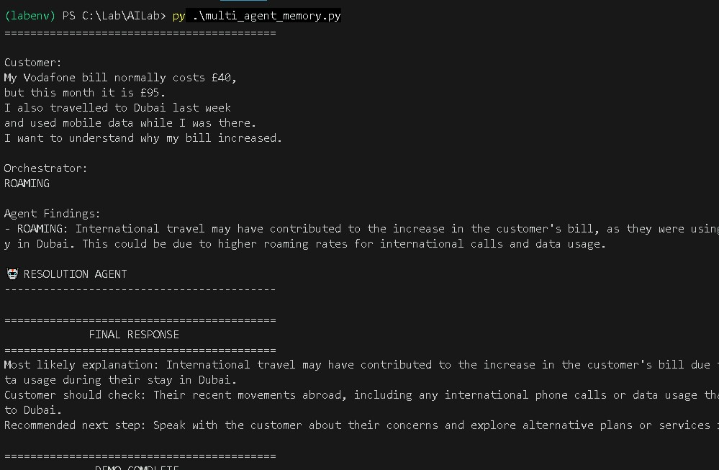
Figure 2 — The live demo: short-term memory shown mid-run, followed by the Resolution Agent's final response, built from the full accumulated context.

8. Important Caveat: This Is Not Production Memory
Be precise with your students here: short_term_memory is a simple demonstration of the concept, not a production memory system. It exists only while this Python process is running:
Python starts
↓
Memory exists
↓
Agents use memory
↓
Python stops
↓
Memory disappears

Instructor note
That limitation is actually a great setup for later introducing real persistent / session memory services — the dictionary here is deliberately the simplest possible version of the idea, not the production version.

9. Where This Leads
This lab completes a clear teaching progression that students can now see end-to-end:
- Local LLM — a small model running entirely offline.
- Agent — the model given a role via a system prompt.
- Orchestrator — an agent whose job is to route, not to answer.
- Multi-Agent — several specialists, one of which is selected at runtime.
- Context Passing — one agent's output becomes another agent's input.
- Short-Term Memory — a shared structure that accumulates context across the whole run.
- Production Multi-Agent System — the same shape, backed by a persistent memory service instead of a Python dictionary.

10. Summary
Students leave this lab having turned a single-shot Orchestrator demo into a system where agents build on each other's work. The short_term_memory dictionary makes two previously invisible ideas — context passing and short-term memory — visible and inspectable in the console, which is exactly what makes them teachable live.
Suggested next step
Once comfortable with this in-process dictionary, students can discuss what changes when memory needs to survive across separate runs or separate users — the first step toward a persistent, session-based memory service in a production multi-agent system.

